**SOURCE PAGE – Year 10**

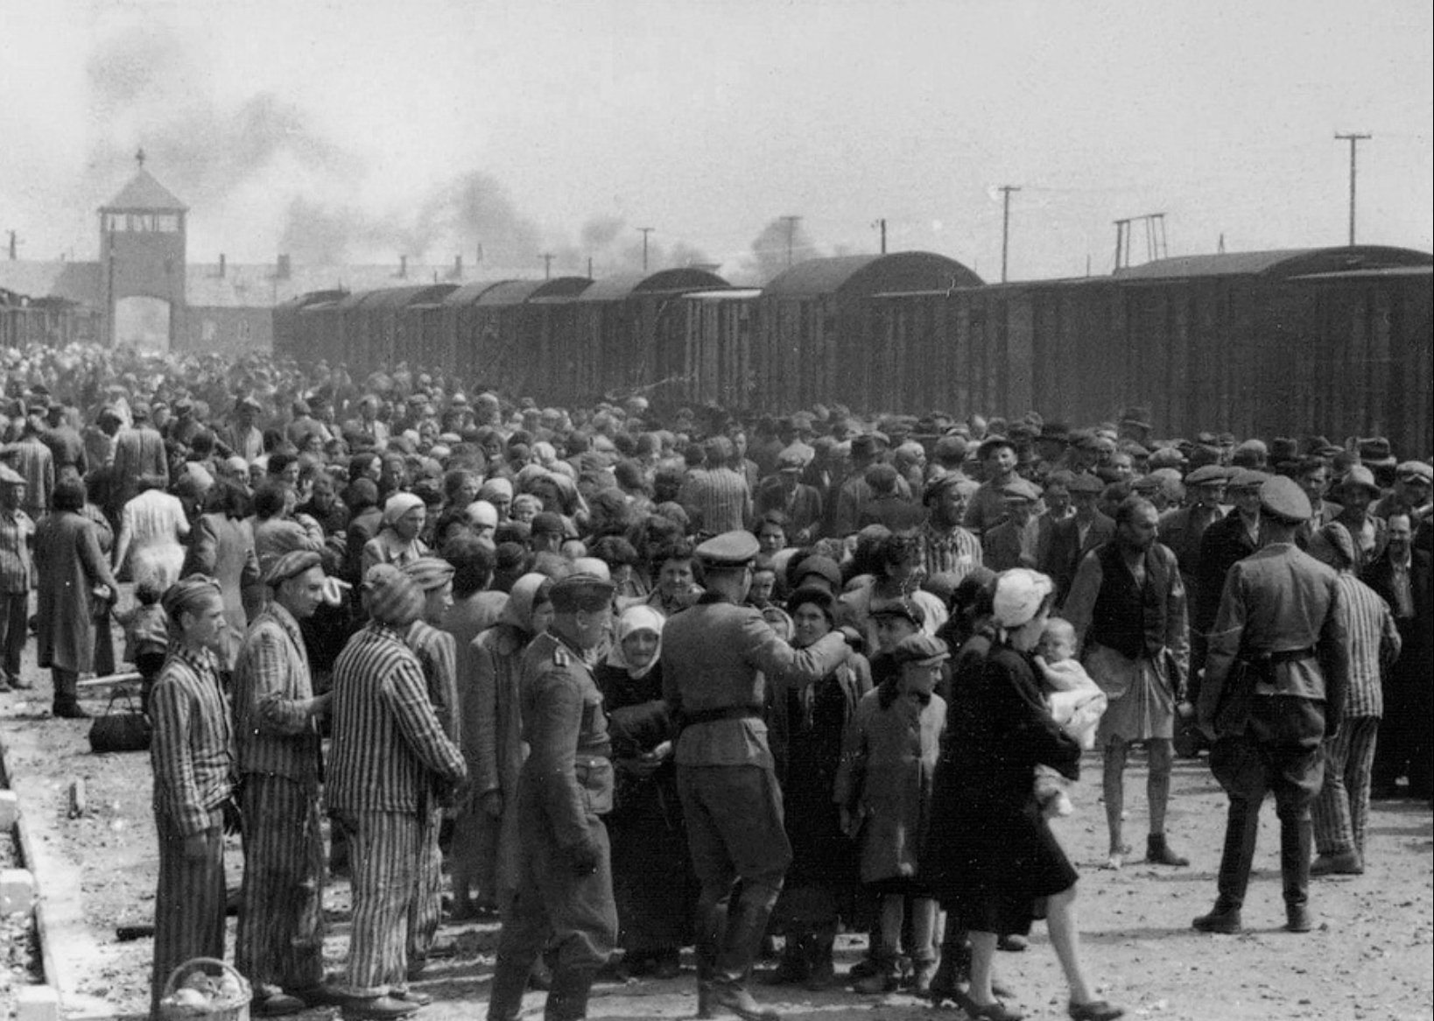

**Source 1**: A photograph taken in 1944 by an unknown photographer. The image was taken at the Auschwitz-Birkenau concertation camp in Poland and shows Hungarian Jews leaving the trains and entering the camp.

**Source 2:** An excerpt from the webpage, ‘The Burma-Thailand Railway and Hellfire Pass’, from the Australian Government Department of Veterans Affairs, <https://anzacportal.dva.gov.au/history/conflicts/burma-thailand-railway-and-hellfire-pass/burma-thailand-railway-and-hellfire-7>

“Japanese soldiers are widely remembered as being cruel and indifferent to the fate of Allied prisoners of war. Many men in the railway workforce bore the brunt of pitiless or uncaring guards. Cruelty could take different forms, from extreme violence and torture to minor acts of physical punishment, humiliation and neglect.

However, it should be recognised that Japanese behaviour varied from place to place and from person to person. Some prisoners recounted instances of compassion by the Japanese and even a sense of sharing a burden.

The reasons for [the Japanese](https://anzacportal.dva.gov.au/history/conflicts/burma-thailand-railway-and-hellfire-pass/burma-thailand-railway-and-hellfire-6) behaving as they did were complex. The Imperial Japanese Army (IJA) indoctrinated its soldiers to believe that surrender was dishonourable. POWs were therefore thought to be unworthy of respect.

The IJA also relied on physical punishment to discipline its own troops. Allied prisoners formed the bottom rung of the military hierarchy and could be punished by any Japanese soldier.

Physical punishment was meted out for even minor infractions, such as failing to salute a Japanese guard — something that caused the Japanese to lose face. The most common form of punishment was face-slapping, often done with a hard instrument, such as a bamboo stick or a shovel.”